INTERFACE BOARD PCB

- PARTS:

QUANTITY: PART #: NOMENCLATURE: LENGTH:

1 PER MACHINE 14046- CAP, RADIAL, 220μF, 16V N/A

2 PER MACHINE 13521- CAP, CER., .01μF, 50V N/A

2 PER MACHINE 17669- HEADER, 34-PIN, STRAIGHT N/A

2 PER MACHINE 15356- RESISTOR, 2.2KΩ, ¼W N/A

2 PER MACHINE 10464- IC, -26LS31, 4-CH. SINGLE END N/A

2 PER MACHINE 17683- HEADER, STRAIGHT, 4-PIN, MOLEX N/A

1 PER MACHINE 17681- HEADER, STRAIGHT, 3-PIN, MOLEX N/A

2 PER MACHINE 17682- HEADER, STRAIGHT, 2-PIN, MOLEX N/A

2 PER MACHINE 17680- CONNECTOR, DB-37, MALE N/A

1 PER MACHINE 217011-2 PCB, BLANK, INTERFACE BOARD N/A

4 PER MACHINE 43071- SCREW, BD HD, 4-40X5/16 LG, SS N/A

- ASSEMBLY:

- INSERT AND SOLDER THE RESISTORS INTO THEIR ASSIGNED PLACES, WITH THE RED STRIPES AWAY FROM THE R1 AND R2 DESIGNATORS, ACCORDING TO DIAGRAM 1..

- INSERT AND SOLDER THE TWO CAPACITORS (13521-) INTO THEIR ASSIGNED PLACES (C2 & C3), ACCORDING TO DIAGRAM 1.

- INSERT AND SOLDER THE ICS INTO THEIR ASSIGNED PLACES, ACCORDING TO DIAGRAM 1.

- INSERT AND SOLDER THE FIVE MOLEX HEADERS INTO THEIR ASSIGNED PLACES, ACCORDING TO DIAGRAM 1.

- INSERT AND SOLDER THE CAPACITOR (14046-, C1) INTO ITS ASSIGNED PLACE, ACCORDING TO DIAGRAM 1.

NOTE 1
THE CAPACITOR (14046-,C1) IS A POLARIZED CAPACITOR. IT MUST BE INSTALLED ONTO THE PCB WITH THE CAPACITOR’S MINUS ARROWS POINTING AWAY FROM THE PCB’S POSITIVE (+) DESIGNATOR.

- INSERT AND SOLDER THE TWO HEADERS (17669-) INTO THEIR ASSIGNED PLACES, ACCORDING TO DIAGRAM 1.

G. INSERT, SCREW, AND SOLDER THE TWO DB37CONNECTORS (17680-), ACCORDING TO DIAGRAM 1.
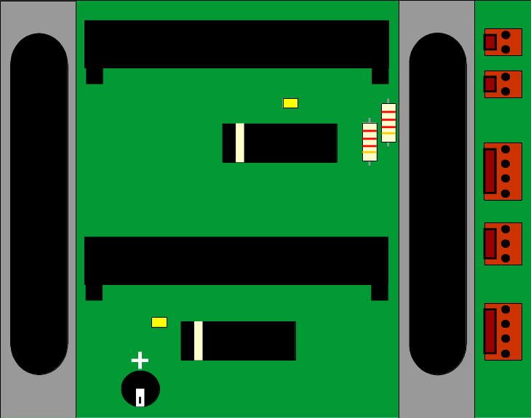

DIAGRAM 1

